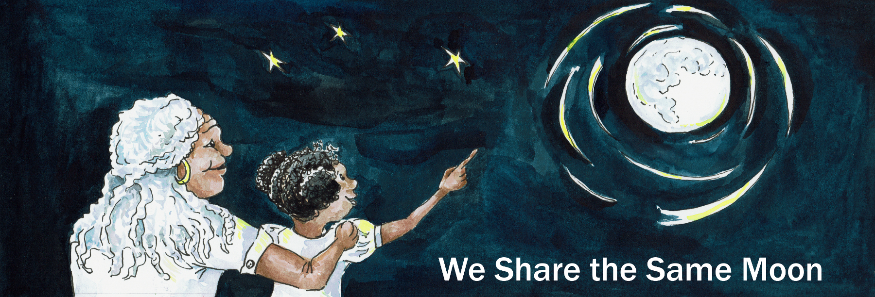
Suggested Age Range: 9 - 10 years; 10 - 11 years; Adult;
UK Curriculum: Key Stage Two (Upper);
Suggested UK Year Groups: Year Five
UK Primary Curriculum Links: Earth and Space
Science Subject: Constellations
Science Questions: What are Constellations?
Suggested Science Activity: Constellations
Children with SEND: Use to boost comprehension of science vocabulary
EAL children: For intermediate learners
Country of Origin: First Nations of America
Source: Keepers of the Animals by M. Caduto and Joseph Bruchac

Long ago, when the world began, before the Humans came…
There was nothing but Winter, and Winter had spread far across the land.
The trees were bowed down with snow, the leaves were brown and the few berries and fruit that grew, soon withered and died. The rivers and lakes were ice, and those that lived in them suffered and many of them died.

Those animals that survived had to be the best of hunters, and the best hunter of them all was Fisher, for he lived on both land and water, and could run upon the frozen land and swim through the icy water.

But, Fisher had a child, a son. And Fisher’s son, was too young to be as good a hunter as his father. Days passed and he found no food. And then, at last he saw something to eat! A squirrel, who was so busy searching in the snow for nuts to eat, that he did not seem to hear the sound or smell of fisher’s son coming closer and closer and closer …

And then Fisher’s son pounced!
He grabbed hold of Squirrel and was about to bite, when Squirrel said:
“Stop! If you do not eat me, I will give you some very good advice!”
And Fisher’s son stopped! And Squirrel said “You want more food to eat?”
“Yes!” said the Fisher’s son.
“Then you must ask your father to help” said Squirrel “Your father is the only one who can go to Sky-land and bring back Summer, to bring light and warmth and food for us all!”
“What must I do?” And Squirrel told him what to do.

That night, Fisher’s son returned to their den, and sat and wept and wept. He refused to tell his mother why he was crying. Fisher returned and offered his son a fish to eat. But still he cried and cried. Until at last Fisher asked” Why are you crying?”

“Because, Father, you are the only one who can go to Sky-land and bring us Summer, and you will not go. Please Father, go to Sky-land and save us all!”
Fisher looked at his son. “This is a very dangerous thing you ask of me, but I will go. But I cannot go alone.”

And so Fisher went to his friends, Wolf, Lynx and Otter and they agreed to help. And together they set off across the frozen landscape, Wolf, Fisher and Otter running, their feet padding across the snow, Lynx leaping from tree to tree.

Until at last they came to a mountain, that seemed to stretch up into the sky.
They paused for a while to rest and then they began climbing, Wolf, Fisher and Otter leapt from rock to rock, Lynx darted from tree to tree.

Up and up, they climbed until they reached the top.
And they could see the sky above them and they could feel the warmth of summer hidden amongst the clouds.
“Come on!” cried Fisher. “We must make a hole in sky, to break through to the land above.” Otter jumped up and struck the sky, but he could not break through.
Lynx jumped next, but his claws just scratched the surface of the sky.
And then Wolf, leapt again and again and again, and with his claws, he gauged the hole through the sky. And the sunlight flooded in!

But, it wasn’t enough to melt the snow. So, Wolf leapt through the hole, carrying Otter in his jaws. Lynx leapt into the sky and hauled Fisher up with him. The animals were tiring but they knew that soon the Sky-people would discover the hole and try and stop them.
And so they dug and scratched and clawed at the hole as fast as they could.
The sunlight flooded past them and into the land below.
They could see the snow begin to melt and the water begin to flow.
But, then they heard footsteps thundering towards them.
“Save yourselves!” shouted Fisher “I will distract them!”
And he ran off, shouting and taunting the Sky-people, who chased after him.
Lynx, Wolf and Otter jumped through the hole in the sky to safety in the land below. And then they looked back up to the sky.

Where was Fisher?
They looked up and saw the sky-people chasing after Fisher! As they got closer and closer, Fisher climbed up a tree, hurling himself from branch to branch until he reached the top of the tree where the sky-people could not follow.

“He is safe!” thought the watchers down below. But, one of the sky-people had a bow and shot Fisher down from the tree. And as he fell tumbling towards the ground.

And as he fell, the Creator looked down. He saw the sacrifice that Fisher had made to save his friends. And so he took pity on Fisher. And so Fisher never struck the ground but instead the Creator picked him up and placed him amongst the stars.

And you can still see today, that pattern of stars, that we call Fisher, high in the sky.

And every year you can see Fisher cross the sky, to begin the long journey to bring summer to the Earth once again.

Copyright Cassandra Wye May 2019

